Analysis and Development Report:
“AI-Powered Daily Revenue Prediction Model”
Prepared by:- Mohamed Hassan
Produced To :- HandyHomeCompany
Date:- October 2025

Abstract
This report provides comprehensive documentation of the development process for a Machine Learning model aimed at predicting daily revenue, deployed within an interactive dashboard
using Streamlit. It covers the stages of Exploratory Data Analysis (EDA), the application of advanced feature engineering techniques (Polynomial Features), model training (XGBoost), and critically, the resolution of critical coding issues encountered during deployment to ensure the
accuracy and integrity of the dashboard functionality.

Table of Contents
- Exploratory Data Analysis (EDA)

- Feature Engineering and Model Construction

- Documentation of Streamlit

- Dashboard Adjustments and Fixes
- Conclusion and Recommendations

- Exploratory Data Analysis (EDA)
The `source_code.py` script was utilized for data processing, preparation, and identifying the
relationships between variables. The data analysis revealed several key insights:

  - Statistical Feature Analysis
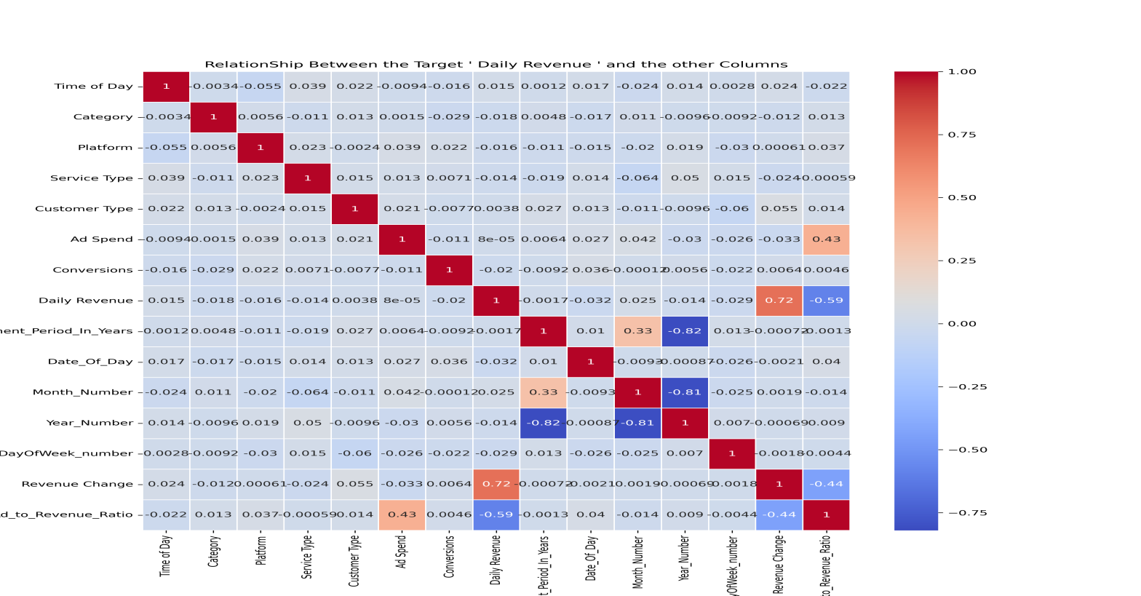

Figure 1: Correlation Matrix between Daily Revenue and other variables.

The matrix highlights
● Moderate Correlation: Most derived temporal variables (e.g., `Date_Of_Day`,`Month_Number`, `DayOfWeek_number`) show relatively low correlations with Daily
Revenue.
● Strongest Predictors: `Ad_to_Revenue_Ratio` and `Revenue Change` exhibit the
strongest correlation with Daily Revenue, underscoring their critical importance in the
prediction process.

  - Categorical Feature Distribution
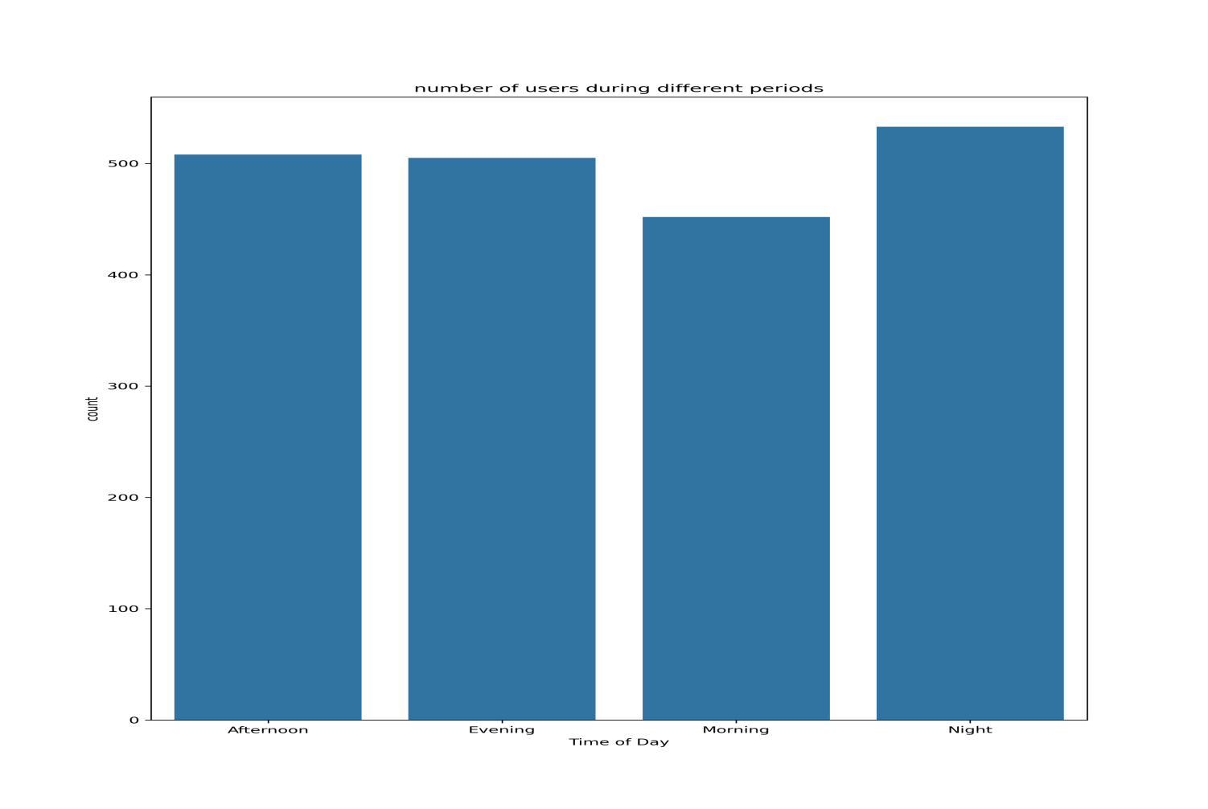
Figure 2: User count distribution by Time of Day

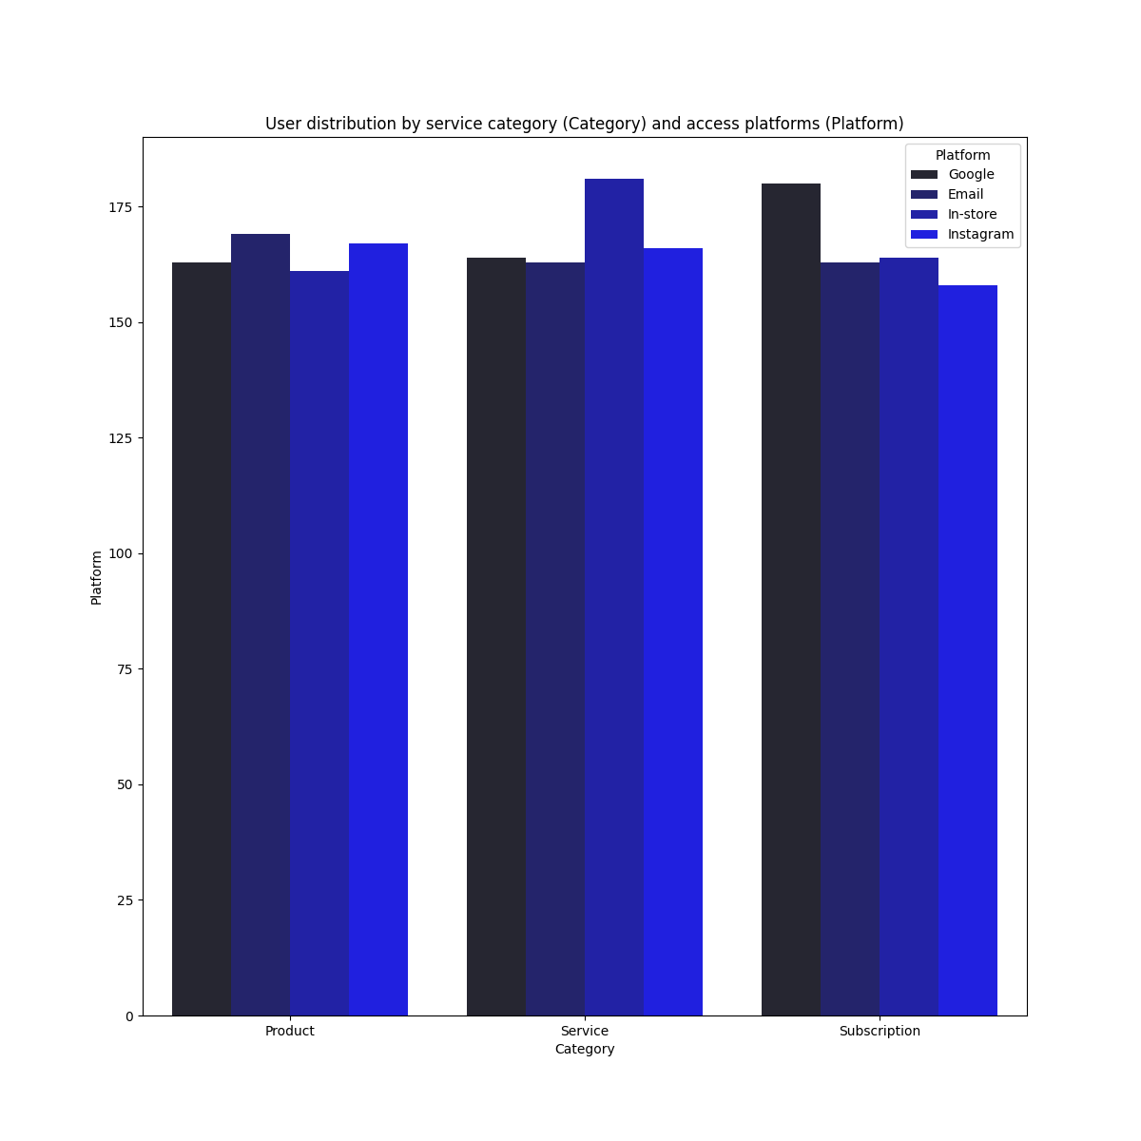
Figure 3: User distribution by (Category) and access platforms (Platform).

  - Effect of Platform Type on Revenue

The figure below shows that different platforms contribute variably across different revenue ranges,confirming the necessity of including this feature in the model.
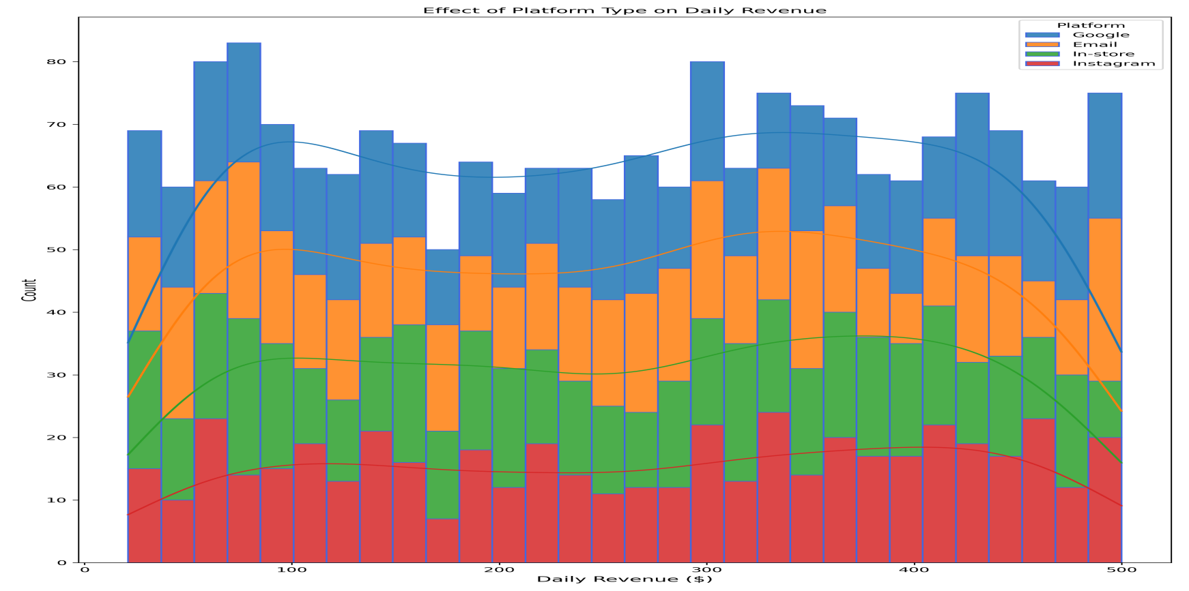

Figure 4: The effect of Platform Type on Daily Revenue.

2. Feature Engineering and Model Construction
2.1 Feature Engineering Steps
The following steps were applied to prepare the data:
- Date Transformation: Multiple temporal features were derived, such as `Date_Of_Day`,`Month_Number`, `Year_Number`, and `DayOfWeek_number`.
2. Derived Variables: `Revenue Change` and `Ad_to_Revenue_Ratio` were calculated.
3. Encoding: Categorical variables (e.g., `Time of Day`, `Category`) were converted into numerical values.
4. Polynomial Features: The `PolynomialFeatures` function with a degree of two was used to create interaction terms among the 14 original features, increasing the total feature count to 120. This step is crucial for the XGBoost model to capture complex, non-linear relationships.

2.2 Training and Results
The XGBoost Regressor model was trained with the following parameters: n_estimators=300, learning_rate=0.05, max_depth=6.
● Training R² Score: 0.94
● Testing R² Score: 0.89
Technical Note: The `poly_transformer.pkl` and `scaler_project.pkl` were saved to ensure that the same transformations are applied to the input data within the Streamlit production environment.

3. Documentation of StreamlitDashboard Adjustments and Fixes

The Streamlit dashboard application encountered a critical error, and fundamental modifications were made to the code to resolve the issue and refine the logic for the Key Performance Indicators (KPIs).

3.1 Fixing the Feature Mismatch Error (14 vs 120)
The error arose because the `StandardScaler` expected 120 features (created by`PolynomialFeatures` , but only 14 raw features were being passed from the user interface.Key Adjustments Made:
- In `source_code.py`: The polynomial feature transformer (`poly`) was saved to a new filenamed `poly_transformer.pkl`. ```python

source_code.py (Adjustment)
poly = PolynomialFeatures(degree=2) x = poly.fit_transform(x) joblib.dump(poly,
'poly_transformer.pkl') ```
- In `main.py`: The `poly_transformer.pkl` was loaded and applied to the 14 raw input features before passing them to the `StandardScaler`. ```python

main_py (Adjustment)
poly_transformer = joblib.load('poly_transformer.pkl')
...
raw_input_data = raw_input_data[feature_names] input_poly =
poly_transformer.transform(raw_input_data) input_scaled = scaler.transform(input_poly) ```

3.2 Improving the "Change \Delta" Metric Logic
The "Change \Delta" metric consistently displayed a static value (0.000). The logic was overhauled to reflect the true meaning of a performance indicator: the difference between the current day's predicted revenue and the last known daily revenue.Key Adjustments Made:
1. Defining Last Known Revenue: The last known daily revenue
(`LAST_KNOWN_REVENUE`) is determined using the `last_value_added()` functiononce at startup.
- New Change Calculation Logic: The formula within the prediction button was changed to Enhanced Visualization as A visual indicator (up arrow ▲ or down arrow ▼) and dynamic colors green/red) were added for clarity. ```python

main_py (Updated Change Metric Logic)
... after calculating pred_value ...
change_value = pred_value - LAST_KNOWN_REVENUE
if change_value >= 0: change_symbol = "▲" change_color = "text-green-500" else:
change_symbol = "▼" change_color = "text-red-500"
c3.markdown(f""" <div class='metric-card'> <h3>Change Δ</h3> <p
class='{change_color}'>{change_symbol} {abs(change_value):.3f} $</p> </div> """,unsafe_allow_html=True) ```

- Conclusion and Recommendations
The development and deployment of the Daily Revenue Prediction Model using XGBoost was successful. Technical issues related to feature dimension mismatch were resolved using the saved `PolynomialFeatures` transformer, and the logic of the "Change \Delta" metric was improved to reflect the actual expected change compared to previous performance.
Future Recommendations:
● Integrate a Continuous Learning feature to automatically update the model with the latest revenue data.
● Explore alternative models, such as Recurrent Neural Networks (RNNs), which are
specialized for time-series data.
● Add a "What-If Analysis" feature, allowing users to adjust inputs like "Ad Spend" and immediately see its impact on the prediction.

User Guide
To operate and interact with the AI Revenue Prediction Dashboard, please follow the steps below:
- Open the AI Revenue Prediction Dashboard
- provided in the deployment section.
- Select the desired business parameters, such as Date, Time of Day, Ad Spend, Category, Platform, Service Type, and Customer Type.
- Click on “Predict Daily Revenue” to generate an AI-based forecast.
- Review the Key Performance Indicators (KPIs) displayed on the dashboard, including the predicted revenue, advertising ratio, and the daily change (Δ) indicator.
- Use these insights to make informed, data-driven business decisions and adjust marketing or service strategies accordingly.
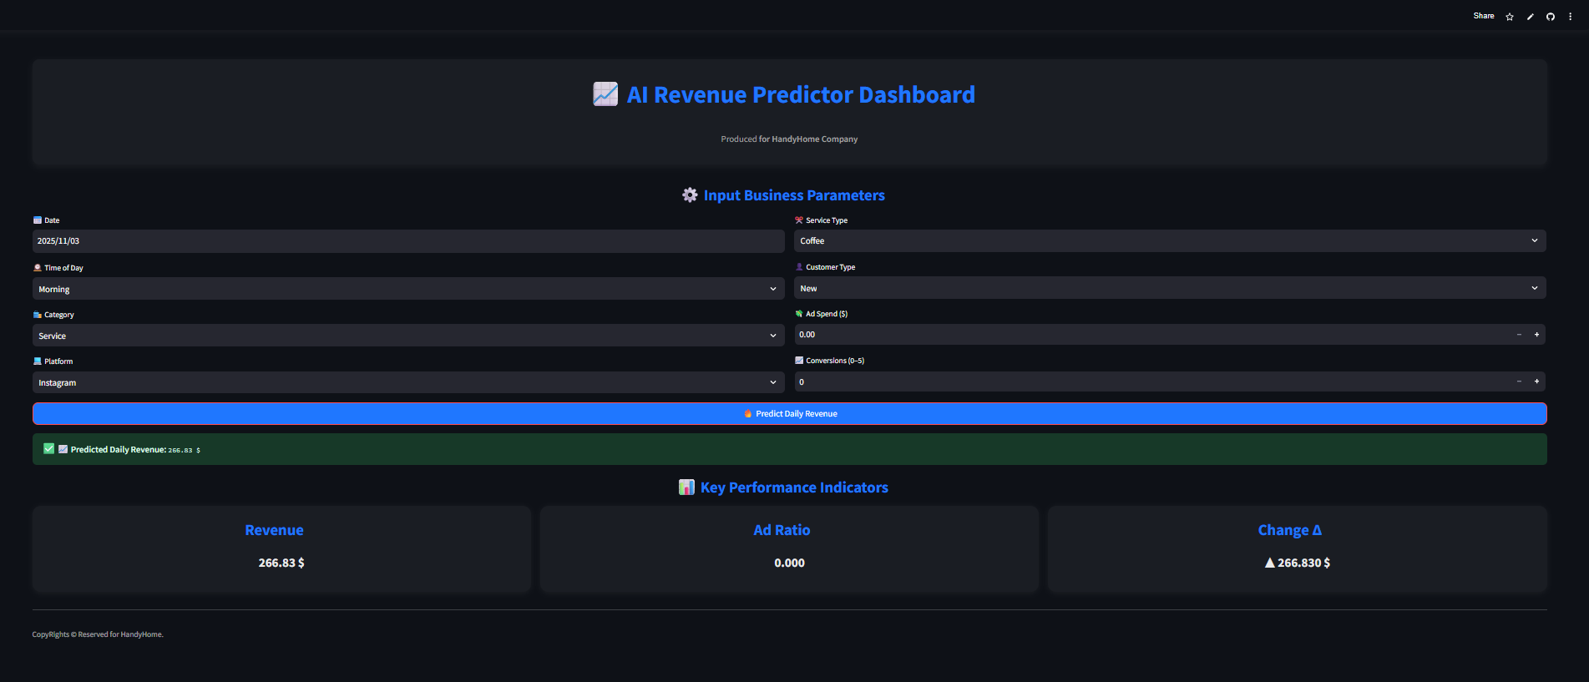

This report presented the development and implementation of an AI-powered Revenue Prediction System designed for HandyHome Company.
The solution integrates advanced data preprocessing, feature engineering, and a finely tuned XGBoost regression model to accurately forecast daily revenue and identify key performance drivers.

Through the deployment of an interactive Streamlit dashboard, the system transforms complex data into actionable insights, empowering management to make data-driven strategic decisions with greater confidence and agility.

The project demonstrates how artificial intelligence can effectively enhance business intelligence processes and revenue forecasting accuracy.
Future improvements may include the integration of real-time data streams, automated model retraining, and enhanced visualization capabilities to further strengthen long-term business growth and performance monitoring.

Prepared by:-

Eng. Mohamed Hassan
Artificial Intelligence & Machine Learning Engineer
Date:- November 2025

